**Bill of Materials Report Aug 10, 2023**

|  |  |  |  |  |  |  |  |  |  |  |  |  |  |  |  |  |  |  |  |  |  |  |  |  |  |  |  |  |  |  |  |  |  |  |  |  |  |  |  |  |  |  |  |  |  |  |  |  |  |  |  |  |  |  |  |  |  |  |  |  |  |  |
| --- | --- | --- | --- | --- | --- | --- | --- | --- | --- | --- | --- | --- | --- | --- | --- | --- | --- | --- | --- | --- | --- | --- | --- | --- | --- | --- | --- | --- | --- | --- | --- | --- | --- | --- | --- | --- | --- | --- | --- | --- | --- | --- | --- | --- | --- | --- | --- | --- | --- | --- | --- | --- | --- | --- | --- | --- | --- | --- | --- | --- | --- | --- |
| **Heatmap** | |  |  |  |  |  |  |  |  |  |  |  |  |  |  |  |  |  |  |  |  |  |  |  |  |  |  |  |  |  |  |  |  |  |  |  |  |  |  |  |  |  |  |  |  |  |  |  |  |  |  |  |  | | --- | --- | --- | --- | --- | --- | --- | --- | --- | --- | --- | --- | --- | --- | --- | --- | --- | --- | --- | --- | --- | --- | --- | --- | --- | --- | --- | --- | --- | --- | --- | --- | --- | --- | --- | --- | --- | --- | --- | --- | --- | --- | --- | --- | --- | --- | --- | --- | --- | --- | --- | --- | | **-95** |  |  |  |  |  |  |  |  |  |  |  |  |  |  |  |  |  |  |  |  |  |  |  |  |  |  |  |  |  |  |  |  |  |  |  |  |  |  |  |  |  |  |  |  |  |  |  |  |  |  | **-45** | | | | | | | | | | |
| **Data-Rates** |  | **1.3Gb** |  | **850Mb** |  | **450Mb** |  | **300Mb** |  | **108Mb** |  | **54Mb** |

**Campus: default__58aeca167c4811ed957ab6cd43cbf282**

Data Rate : N/A

Client Xmit : 30

**Building: SMJKrekovtrg**

Address : Krekov trg 3

Data Rate : 36

Client Xmit : 30

Geo Code : Long: 15.2670986 Lat: 46.2281836

**Floor 1.0: Krekovtrg3-celjskidom**

Environment : Offices

Data Rate : 36.0 Mbps

Client Xmit : 30

Floor Height : 10.00 Meters

Image Area : 53,792 Sq Meters

Total Controllers : 0

Total IDFs : 0

Total Racks : 0

Total Switches : 0

Total Ports : 0

Total POE Ports : 0

Total APs : 3

Total AMs : 0

**Floor Plan Only View**

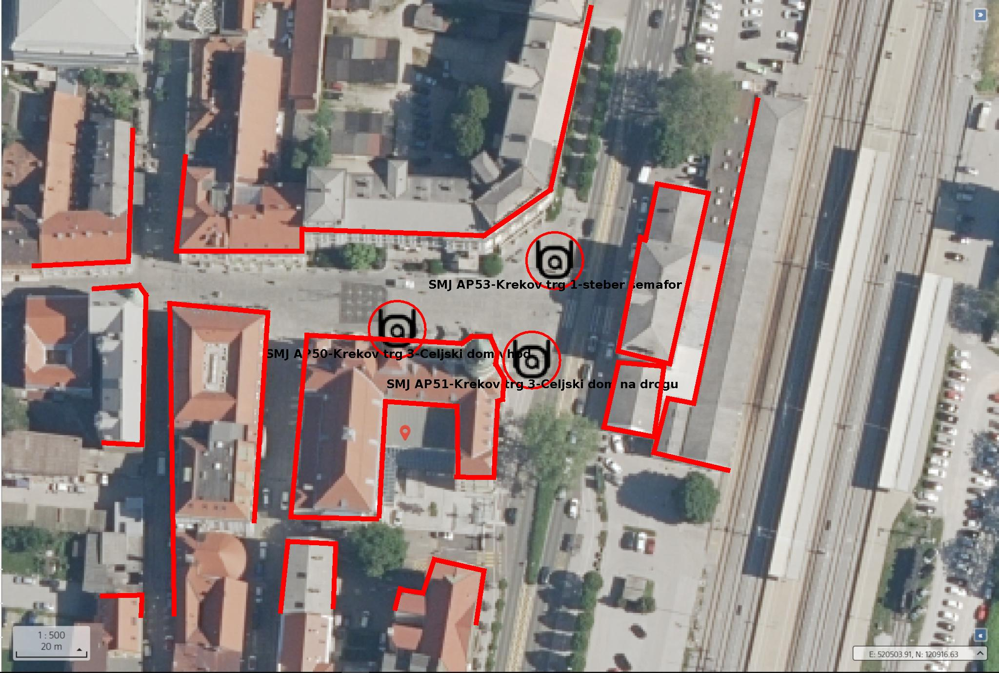

**Data Rate View**

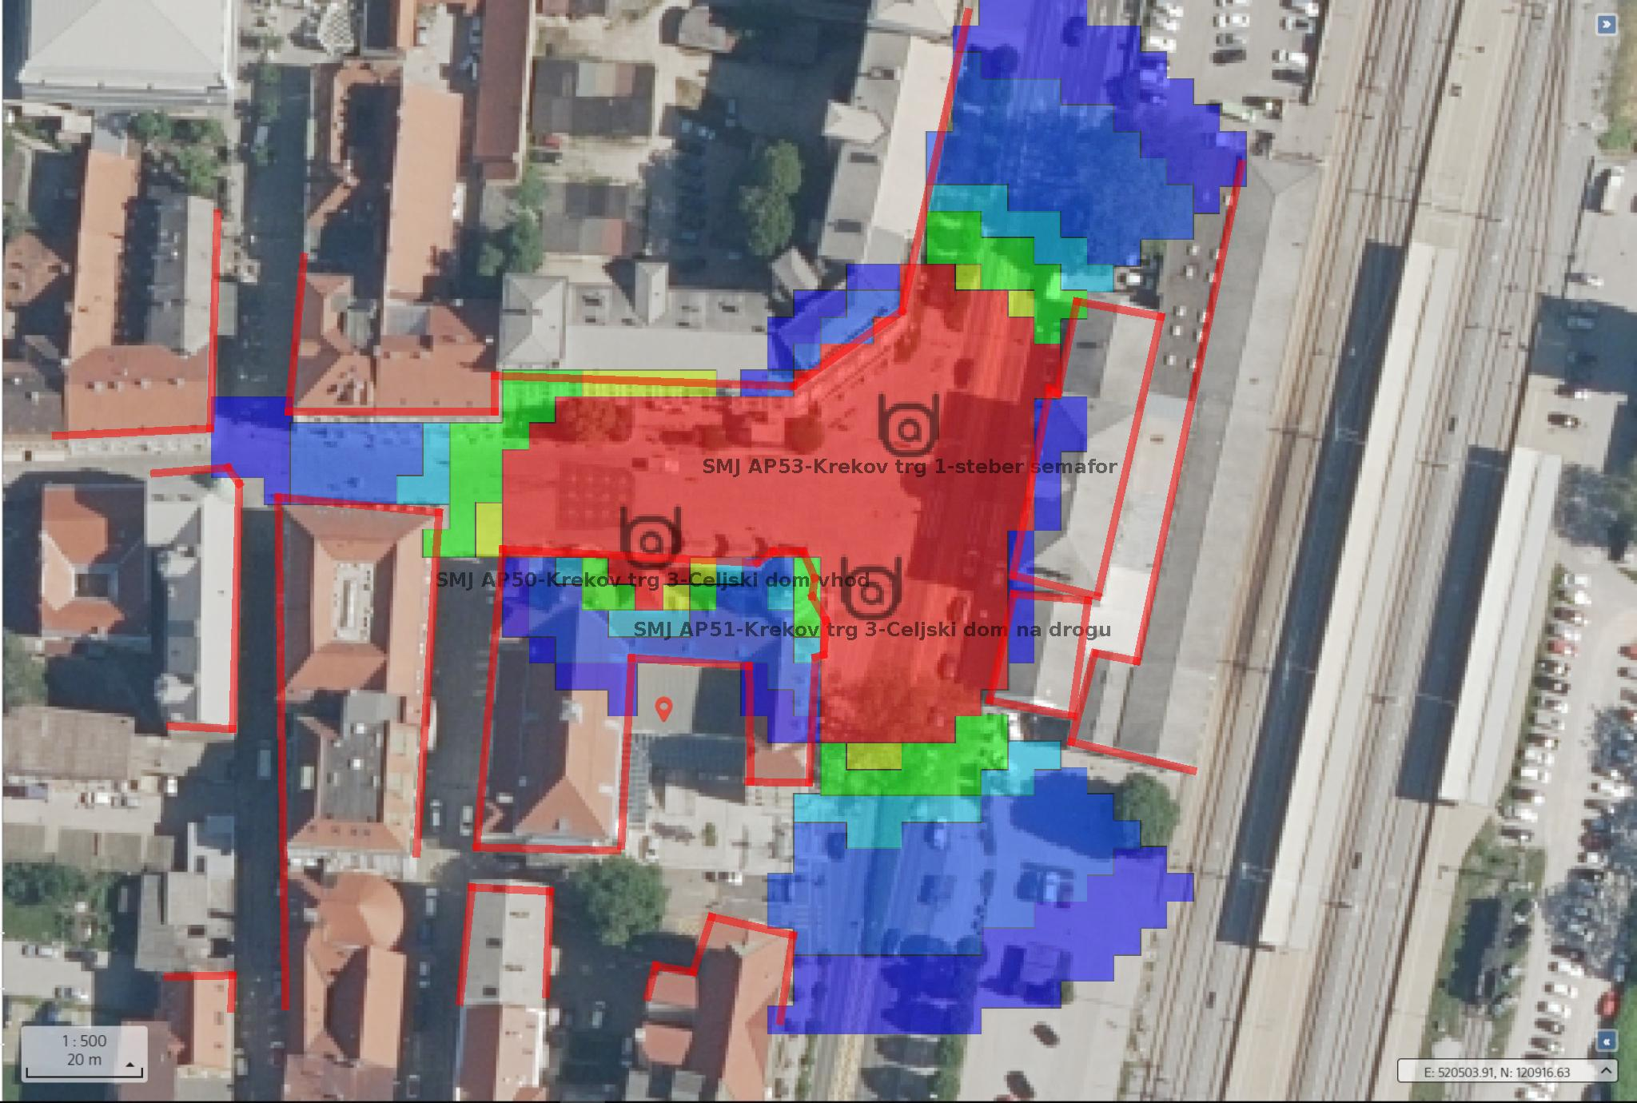

**Heat Map View**

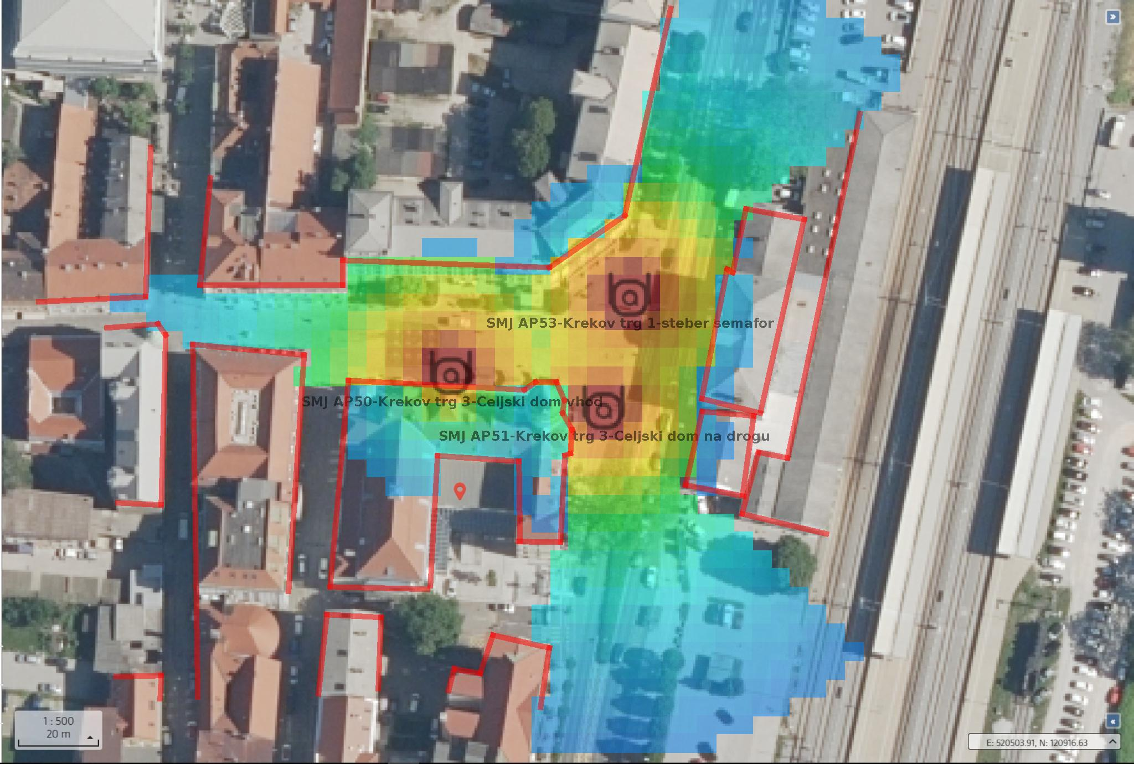

|  |  |  |  |  |  |  |  |  |  |
| --- | --- | --- | --- | --- | --- | --- | --- | --- | --- |
| AP Inventory | | | | | | | | | |
| **Name** | **Model** | **Part #** | **PHY** | **Ch** | **Xmit dBm** | **Ga in dBm** | **LAN MAC** | **Switch** | **Port** |
| SMJ AP50-Krekov trg 3-Celjski dom vhod | Aruba AP 575 | AP-575 | 802.11ax(2.4)  802.11ax(5.0) | 1  136 | 20.0  30.0 | 2.7  2.7 | 48:2F:6B:C1:18:80 |  |  |
| SMJ AP51-Krekov trg 3-Celjski dom na drogu | Aruba AP 575 | AP-575 | 802.11ax(2.4)  802.11ax(5.0) | 6  157 | 20.0  14.0 | 2.7  2.7 | 48:2F:6B:C1:18:B2 |  |  |
| SMJ AP53-Krekov trg 1-steber semafor | Aruba AP 575 | AP-575 | 802.11ax(2.4)  802.11ax(5.0) | 1  136 | 20.0  30.0 | 2.7  2.7 | 48:2F:6B:C1:11:14 |  |  |

|  |  |  |  |  |  |  |  |  |  |
| --- | --- | --- | --- | --- | --- | --- | --- | --- | --- |
| Wired Inventory | | | | | | | | | |
| **Name** | **Model** | **Part #** | **# POE Ports** | **Total Ports** | **IDF** | **Rack** | **Rack Unit #** |

|  |  |  |  |  |  |  |  |  |  |
| --- | --- | --- | --- | --- | --- | --- | --- | --- | --- |
| Floor Total | | | | | | | | | |
| **Part #** | **Type** | **Mode** | **Qty** |
| AP-575 | Aruba AP 575 | AP  AM | 3  0 |

|  |  |  |  |  |  |  |  |  |  |
| --- | --- | --- | --- | --- | --- | --- | --- | --- | --- |
| Summary | | | | | | | | | |
| **Part #** | **Type** | **Mode** | **Qty** |
| AP-575 | Aruba AP 575 | AP  AM | 3  0 |